**PH233 End-semester exam Module A: Actuator**

**Objective:**

Setup a circuit that gives precise control of current through an LED such that brightness of light emitted by the LED can be precisely controlled.

An LED is a type of diode. As we have learnt, a diode I-V characteristics dictate that once the forward bias voltage across an LED exceeds a threshold voltage Vth it starts conducting. The brightness of light from the LED is proportional to the conduction current (we assume the relation is approximately linear for this experiment)

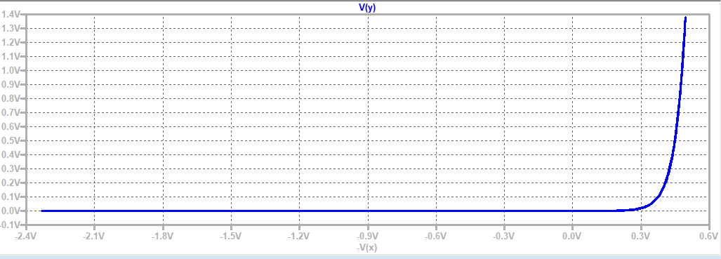

Fig 1: Typical LED I-V characteristic: The turn-on threshold voltage will vary depending on Red/Green LED’s and may be different for different LED’s. Aim of this module is to devise an opamp based LED driving circuit that operates in the shaded red band – ILED is directly controlled, without caring about Vth

→ Vforward-bias

Vth

ILED   
~ mA

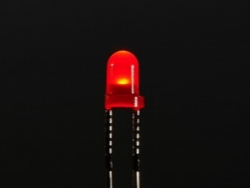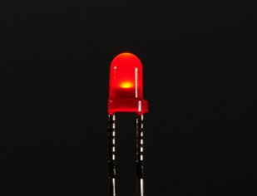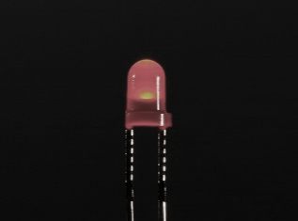

LED brightness ∝ ILED

Dim

Medium

Bright

**Practical specifications:**

In earlier labs, we were mostly concerned with turning an LED ON or OFF, and putting a safety limit on the forward current with a series current limiting resistor.

Our goal is *different* in this experiment. We want to control the brightness of the LED which is (approximately) proportional to ILED in forward bias after turn on.  
We will be working with voltage levels between modules of the overall feedback system. So we don’t want to waste Vth (~1.8V for red LED) simply to turn it on and then have a very narrow band of voltage control highlighted in red in Fig 1 to control its current.

Use the following ingredients to design and build an actuator module that controls the brightness of a red LED by precisely controlling the current ILED in the red band highlighted in Fig 1. i.e. ILED is directly controlled (not VLED)

**Design ingredients for actuator:**

1. Single Opamp LM741 must be used
2. Input voltage to the circuit Vin|actuator must span 0V to 4V. LED must turn on immediately when Vin|actuator rises above 0V and its brightness (∝ ILED) must increase approximately linearly up to Vin|actuator = 4V   
   (i.e. Vth of the I-V characteristic must not be supplied directly from VCC
3. HINT: This can be done by including the LED in your opamp feedback loop. Figure out how and why this works.

**Simulation: 5**

Draw your LTSpice simulation circuit design here. Provide a simulation plot of ILED v/s Vin|actuator validating the control range of your circuit.

Use component values such that ILED|max ~ 10 mA to avoid saturation of the photo-transistor and to remain well within the maximum current that can be supplied by the opamp. Measure the voltage across a suitably connected resistor to probe ILED when you build the circuit.

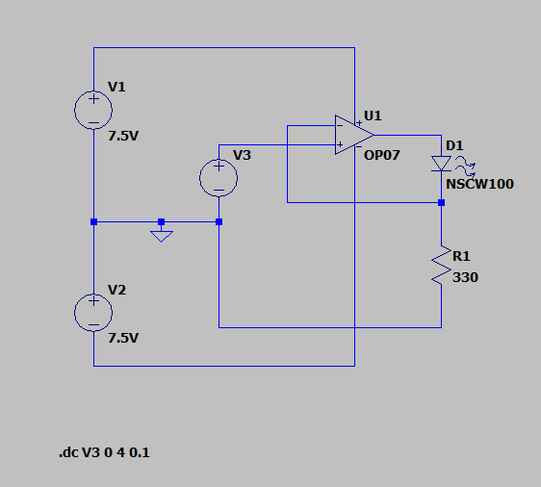

*NOTE: Voltage source of 7.5V has been used instead of the usual 9V due to my actual battery source draining out after a lot of usage.*

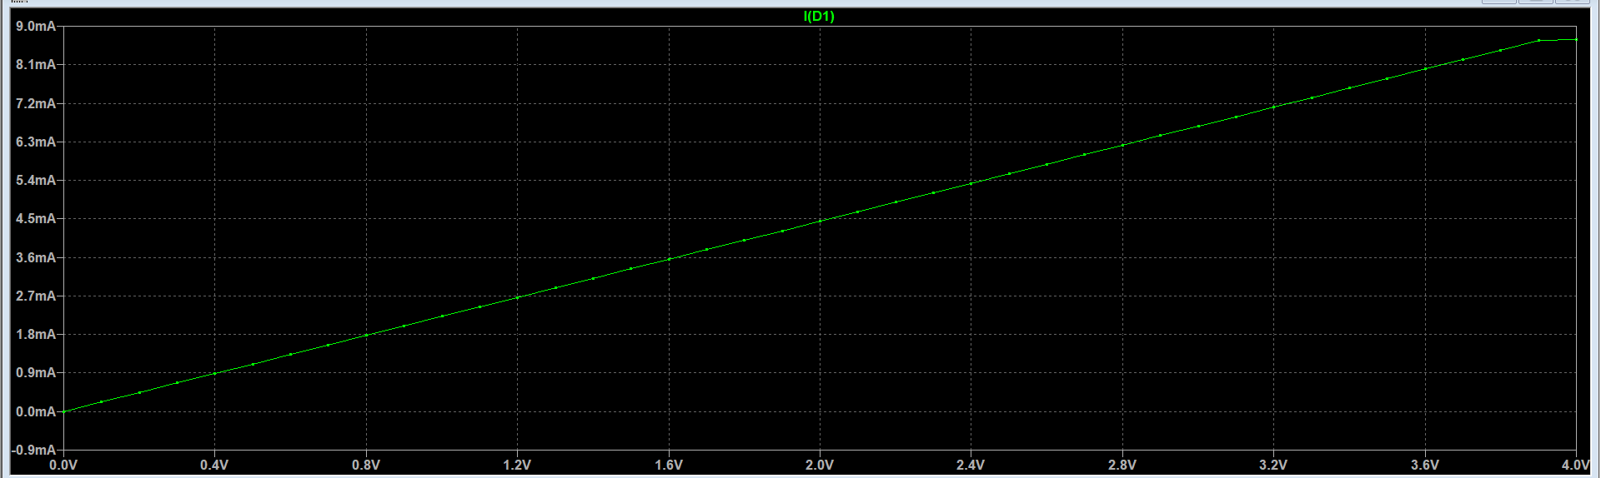

**Demo 5**

Build your circuit as per the above design. Use a 10kΩ potentiometer to vary DC voltage input Vin|actuator to your circuit. Measure Vin|actuator and ILED=Vshunt/Rshunt with DMM  
Fill the following table listing your measurements for a few settings between 0V and 4V

Vin|actuator = 0V ILED = 0mA

Vin|actuator = 1V ILED = 2.1mA (as Vshunt = 1V)

Vin|actuator = 2V ILED = 4.2mA (as Vshunt = 2V)

Vin|actuator = 3V ILED = 6.4mA

Vin|actuator = 4V ILED = 10mA

Post a sequence of photos for a few of the above measurements, indicating Vin|actuator applied (measured with DMM), and the corresponding ILED measured as voltage Vshunt by DMM across the shunt resistor

Does ILED vary approximately linearly with Vin|actuator ?

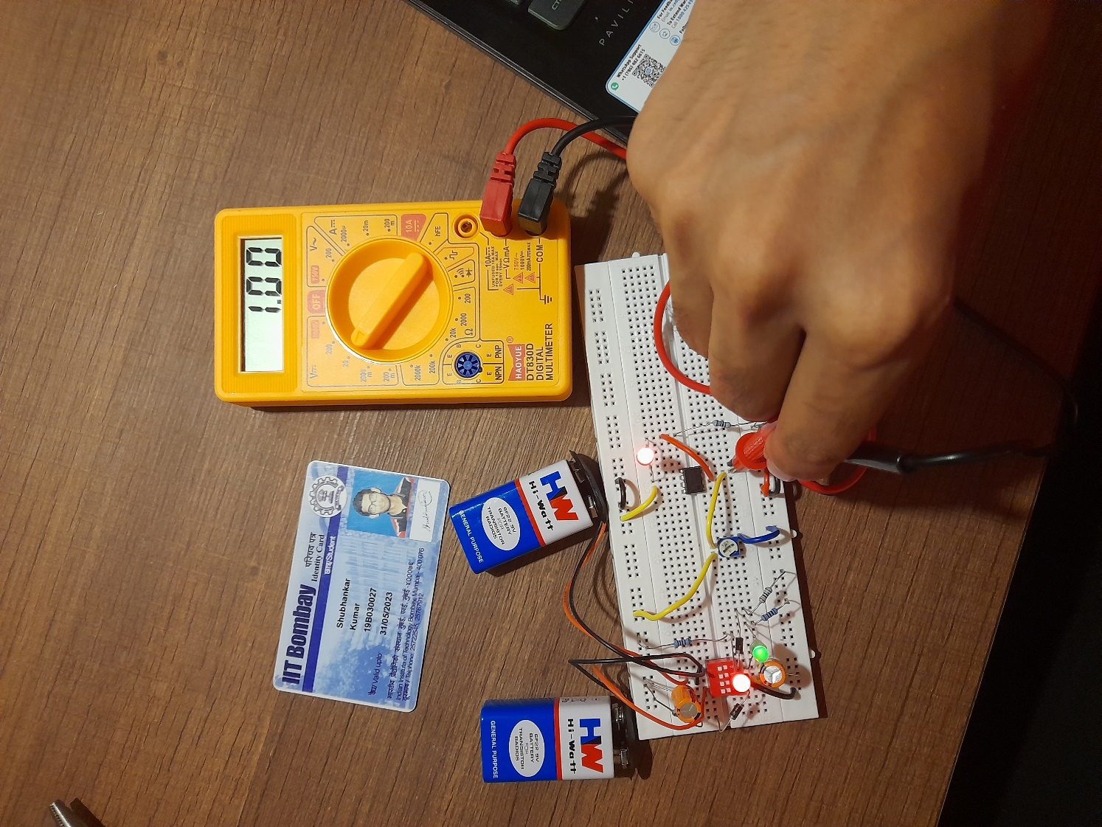

**VIN = 1V**

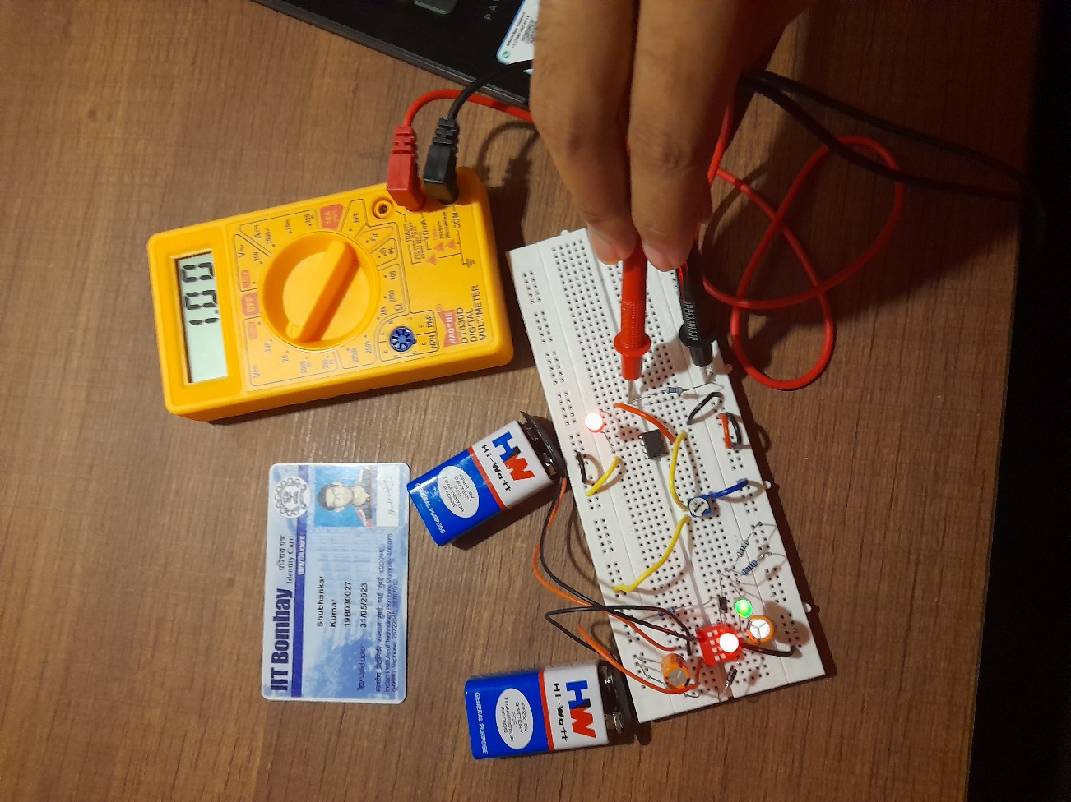

**Vshunt = 1V**

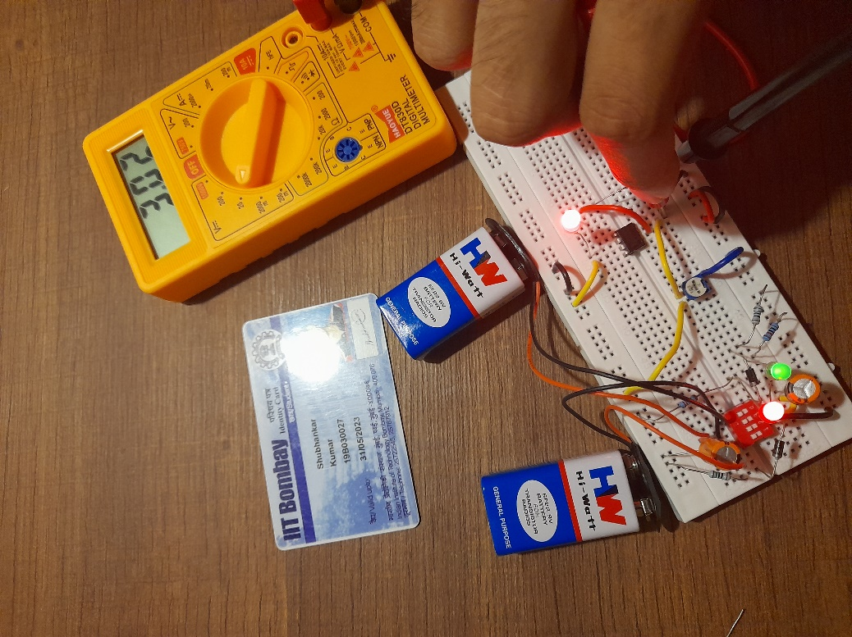

**VIN = 3V**

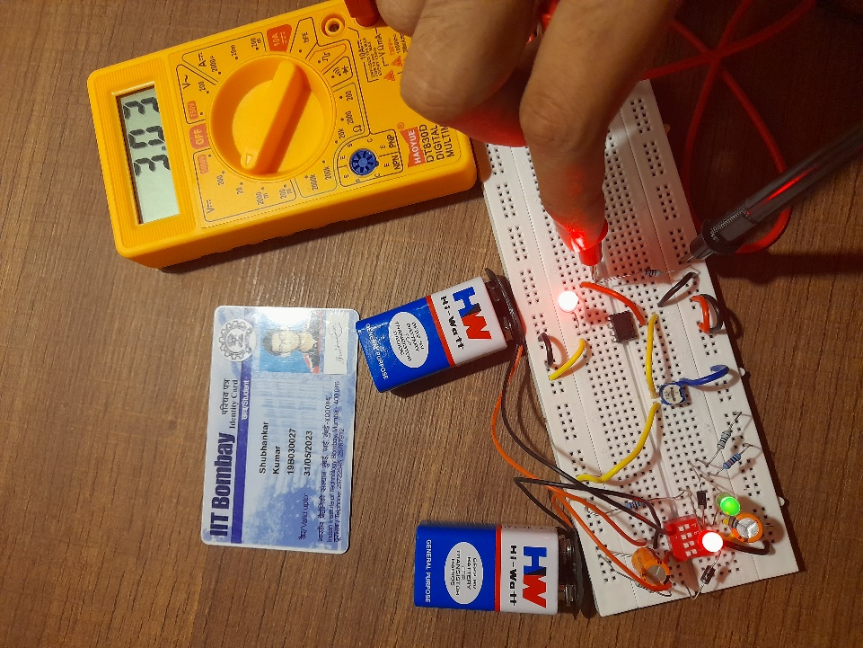

**Vshunt**